Conducting In-Depth Network Analysis
Security Assessment of Wi-Fi and Bluetooth Data Transmission.

Prepared by:
Harsh Dankhra

Date:
10 December 2025

Table of Contents:
1. Title Page -----------------------------------------------------------------------------1
2. Table of Contents -------------------------------------------------------------------2
3. Introduction --------------------------------------------------------------------------3
4. Background ---------------------------------------------------------------------------4
5. Problem Statement -----------------------------------------------------------------5
6. Objectives -----------------------------------------------------------------------------6
7. Scope -----------------------------------------------------------------------------------7
8. Methodology -------------------------------------------------------------------------8
9. Security Analysis ---------------------------------------------------------------------9
10. Threat Analysis ---------------------------------------------------------------------24
11. Findings / Results ------------------------------------------------------------------25
12. Recommendations ----------------------------------------------------------------26
13. Conclusion ---------------------------------------------------------------------------27
14. References ---------------------------------------------------------------------------28

3.Introduction
Wireless communication has become essential for modern financial and business operations. Organizations rely heavily on Wi-Fi and Bluetooth to transfer sensitive information between devices, applications, and internal systems. However, these wireless channels are vulnerable to eavesdropping, unauthorized access, and interception if not properly secured.

The purpose of this project is to perform an in-depth analysis of the security requirements for protecting wireless data transmissions. This includes identifying common vulnerabilities, evaluating encryption and authentication mechanisms, and reviewing industry-standard practices for securing wireless networks.

This document presents research findings, examines potential risks, and provides recommendations to enhance the confidentiality, integrity, and availability of wireless communication within enterprise environments.

4.Background
Wireless networks have become a fundamental part of modern enterprise operations, supporting daily communication and data transfer across multiple devices. Wi-Fi access points, Bluetooth-enabled devices, and wireless communication channels are used daily for data exchange, remote connectivity, and device communication. As businesses scale digitally, the volume of sensitive information transferred over wireless networks continues to increase.

However, the widespread adoption of Wi-Fi and Bluetooth also introduces several security challenges that attackers can exploit if networks are not properly protected. Despite convenience and flexibility, wireless networks introduce unique security challenges. Unsecured access points, weak encryption, default credentials, and outdated protocols make networks vulnerable to interception, eavesdropping, and unauthorized access. Attackers can capture data packets through the air without direct physical access to network hardware.

Given these risks, it becomes essential to analyze wireless communication standards, common attack techniques, and existing security mechanisms to strengthen overall protection. A background study is required to evaluate wireless risks and determine how confidential data can be protected. To secure transmission, it is essential to understand the evolution of wireless standards, common attack techniques, and existing prevention mechanisms. This background provides the foundation for the analysis conducted in subsequent sections of this document.

5.Problem Statement
Many organizations rely on Wi-Fi and Bluetooth technologies for day-to-day operations, yet these wireless networks often lack essential security configurations. Weak or outdated encryption protocols, insecure authentication methods, and limited monitoring capabilities create openings that attackers can easily exploit. As a result, sensitive information transmitted over wireless channels becomes vulnerable to interception and unauthorized access.

For companies that manage confidential or financial data, such vulnerabilities introduce significant risks. Cyber attackers can target wireless networks without needing physical access to internal systems, making it easier to perform eavesdropping, man-in-the-middle attacks, or unauthorized data extraction. These threats can lead to data breaches, service disruption, reputational loss, and failure to meet regulatory compliance.

To address these risks, it is necessary to analyze existing wireless configurations, identify security weaknesses, and determine the requirements needed to protect data transmission. This project aims to bridge the gap between current wireless usage and the security measures required to maintain confidentiality, integrity, and availability within enterprise environments.

6.Objectives
The primary objective of this project is to evaluate the security requirements necessary to protect data transmitted over wireless networks within an enterprise environment. This involves analyzing how Wi-Fi and Bluetooth communication channels handle sensitive information and determining whether existing configurations meet modern security standards.

A key objective is to identify vulnerabilities that may expose wireless transmissions to interception, unauthorized access, or manipulation. By examining encryption methods, authentication mechanisms, and device-level security controls, the project aims to highlight areas where improvements are needed to reduce overall risk.

Another objective is to provide practical recommendations that strengthen wireless network security and support organizational compliance. These recommendations will focus on implementing secure protocols, improving configuration practices, and adopting industry-standard defense measures to ensure confidentiality, integrity, and availability of data transmitted over wireless mediums.

7.Scope of the Study
The scope of this study is limited to analyzing the security requirements and vulnerabilities associated with wireless communication technologies used within enterprise environments. This includes examining Wi-Fi networks, Bluetooth-enabled devices, and the protocols that govern wireless data transmission.

The assessment focuses on identifying risks related to encryption, authentication, network configurations, and device connectivity. It does not cover wired network security, physical security measures, or unrelated IT infrastructure components unless they directly influence wireless communication.

This study also evaluates common attack techniques used against wireless networks and considers industry-standard practices that organizations can adopt to enhance protection. The recommendations provided are intended to improve the security posture of wireless networks and support safer handling of sensitive enterprise data.

8.Methodology
The methodology for this project is based on a structured approach to evaluating wireless network security and identifying potential vulnerabilities. The study begins with researching Wi-Fi and Bluetooth technologies, including their communication mechanisms, encryption standards, and common security weaknesses. This foundational understanding provides the context needed to assess risks accurately.

The next step involves analyzing known attack techniques used against wireless networks, such as eavesdropping, packet sniffing, rogue access points, and man-in-the-middle attacks. By reviewing these techniques, the project identifies how attackers exploit weaknesses in wireless configurations and where organizations must improve their defenses.

Finally, industry best practices and security frameworks are examined to develop practical recommendations. These include secure configuration guidelines, updated encryption protocols, authentication enhancements, and monitoring strategies aimed at strengthening wireless communication security across enterprise environments.

8.1 High-Level Wireless Security Architecture
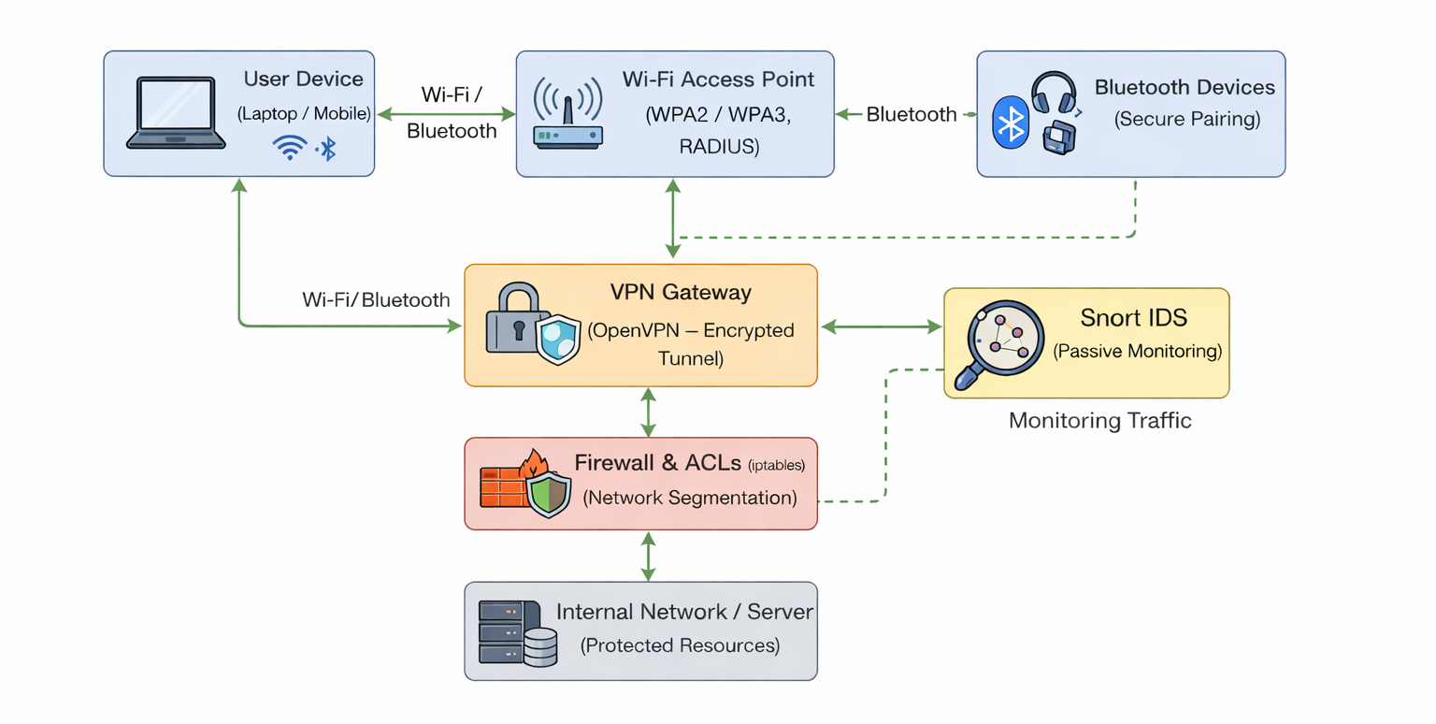
This diagram illustrates the overall security architecture implemented for protecting wireless data transmission within the test environment. User devices connect to the network through secured Wi-Fi and Bluetooth communication channels. Wi-Fi communication is protected using WPA2/WPA3 encryption and enterprise authentication mechanisms, while Bluetooth devices rely on secure pairing and authentication controls.
All wireless traffic is routed through a VPN gateway configured using OpenVPN, which establishes an encrypted tunnel to protect data confidentiality over the wireless medium. Firewall-based Access Control Lists (ACLs) are applied to enforce network segmentation and restrict unauthorized inter-segment communication.
A Snort-based Intrusion Detection System (IDS) passively monitors network traffic at key points in the architecture to detect suspicious or abnormal activity. This layered security approach ensures confidentiality, access control, segmentation, and continuous monitoring of wireless communications in an enterprise environment.

9. Security Analysis
9.1 Wireless Network Vulnerability Assessment

9.1.1 Wi-Fi Vulnerability Assessment (Practical)
Wireless Interface Identification:
Screenshot:
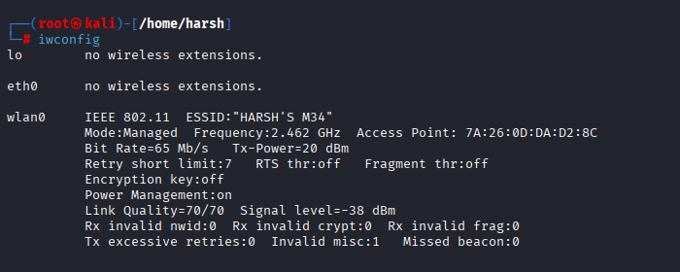
The wireless network interface was identified using the iwconfig command. This step confirms the availability of a compatible Wi-Fi adapter required for conducting wireless security assessments.
Monitor Mode Activation:
Screenshot:
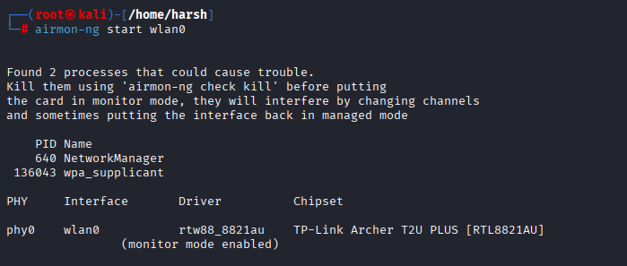
Monitor mode was enabled using the Aircrack-ng suite to allow passive monitoring of wireless traffic. Monitor mode is essential for analyzing Wi-Fi network configurations and detecting potential vulnerabilities.
Wi-Fi Network Discovery:
Screenshot:
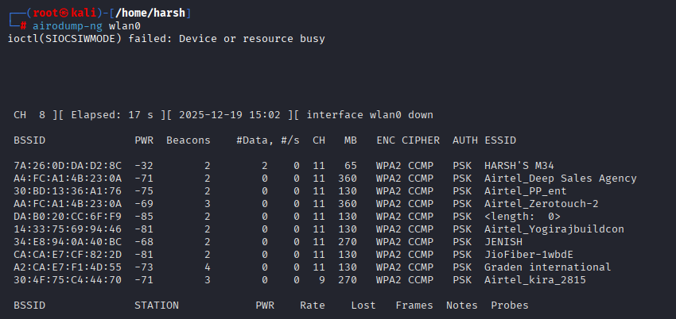
A wireless reconnaissance scan was conducted using airodump-ng to identify nearby Wi-Fi networks. The scan revealed network names, encryption standards, and channels, which are critical indicators of wireless security posture.

9.1.2 Bluetooth Vulnerability Assessment (Practical)
Bluetooth Interface Initialization:
Screenshot:
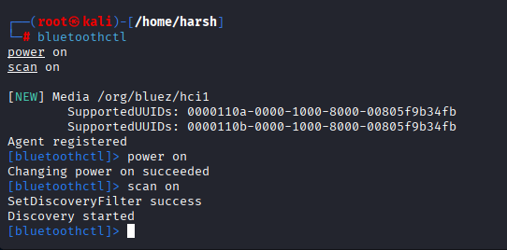
As part of the practical assessment, the Bluetooth interface was enabled using the bluetoothctl utility in Kali Linux. This confirms that the Bluetooth adapter is operational and ready for security testing.
Bluetooth Tool Verification:
Screenshot:
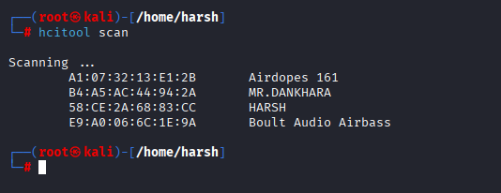
The hcitool utility was used to verify Bluetooth hardware functionality and ensure that the adapter supports classic Bluetooth operations required for device discovery.
Bluetooth Device Discovery:
Screenshot:
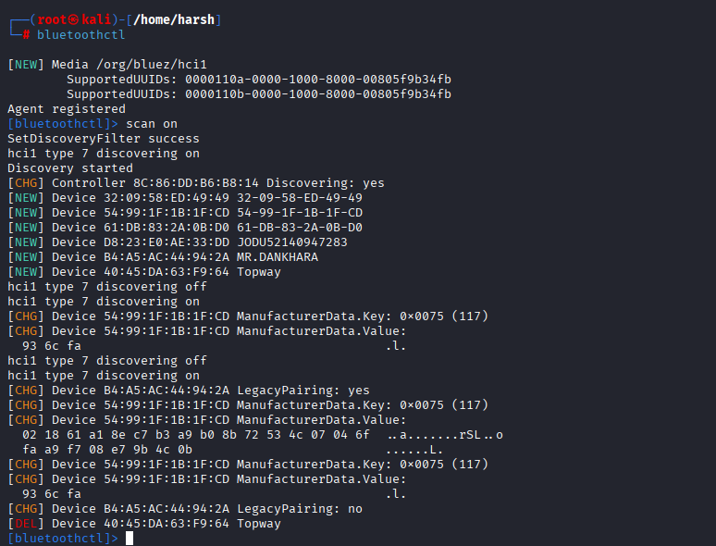
A Bluetooth discovery scan was performed to identify nearby Bluetooth-enabled devices operating in discoverable mode. The presence of multiple devices indicates potential exposure to reconnaissance if discoverability is not restricted.

9.2 Implementing Wi-Fi Encryption:

9.2.1 WPA2 Encryption Configuration

Screenshot:
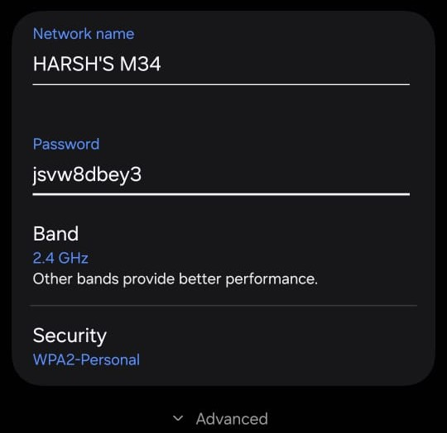

The test Wi-Fi network was configured using WPA2-Personal encryption to secure wireless communication. WPA2 ensures that all connected devices authenticate using a shared secret key and that wireless data is encrypted, protecting it from unauthorized interception.

9.2.2 WPA3 Encryption Configuration

Screenshot:
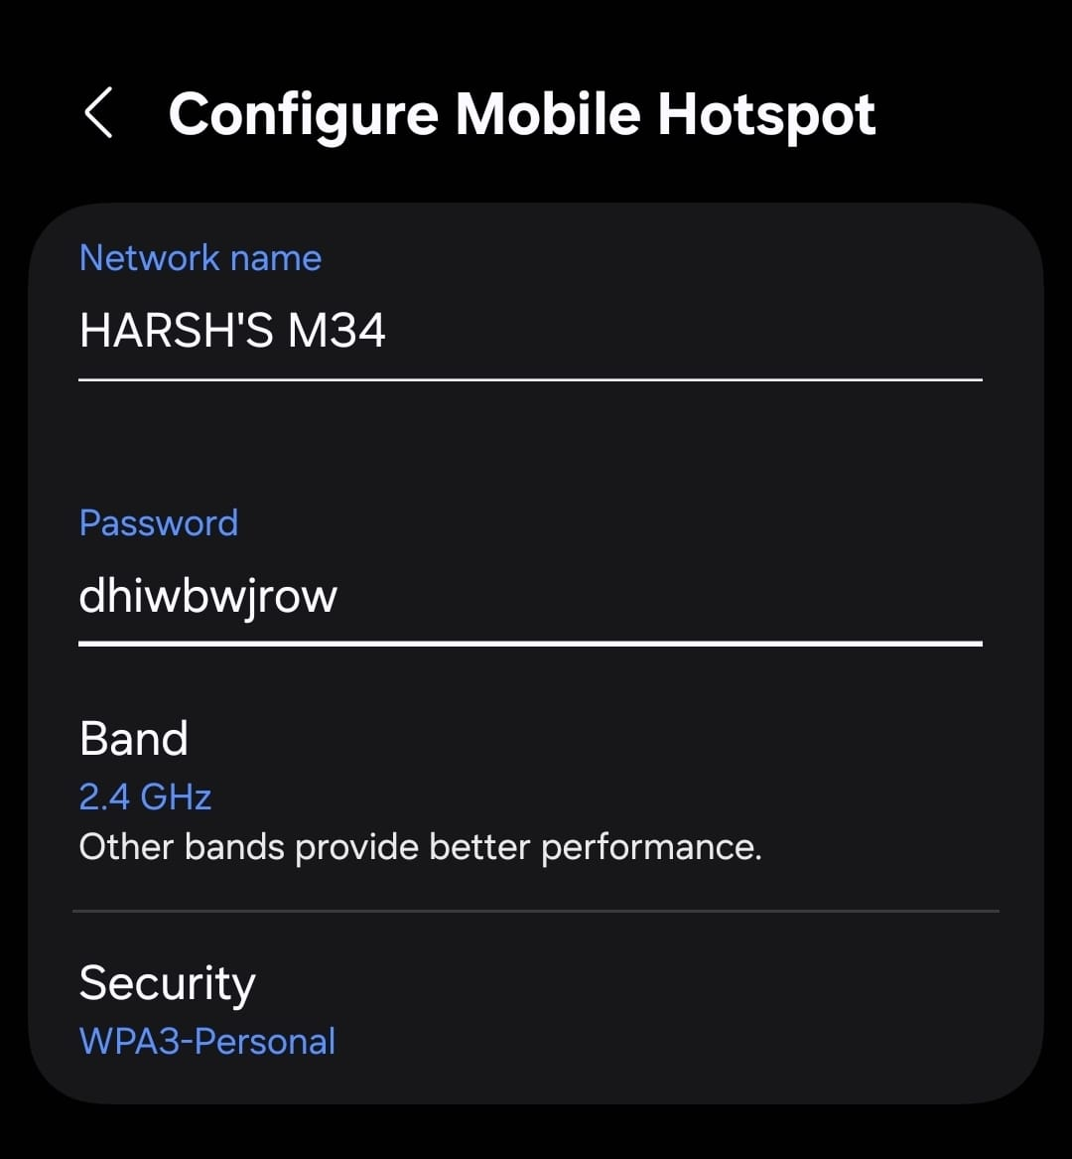

To enhance wireless security, WPA3-Personal encryption was enabled on the test Wi-Fi network. WPA3 provides stronger protection against brute-force and offline dictionary attacks by implementing improved authentication and encryption mechanisms, making it more secure than WPA2.

9.2.3 Practical Observation
Screenshot:
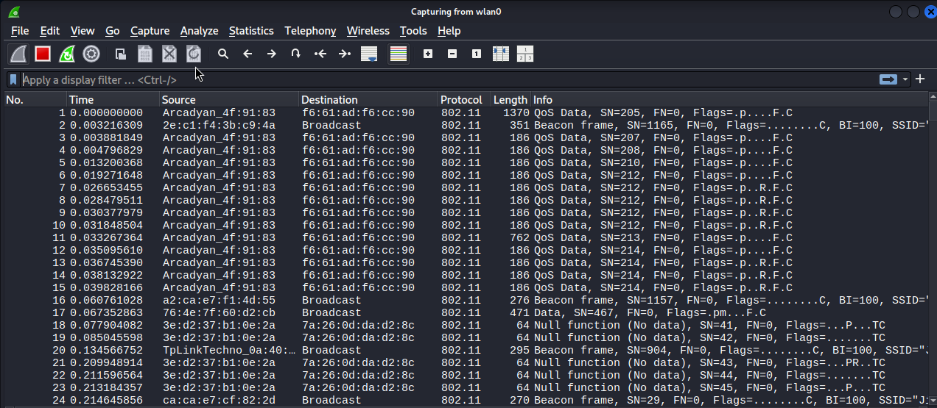
The analysis confirmed that sensitive information such as credentials or application data was not visible during packet capture. This demonstrates that strong encryption mechanisms are actively enforcing confidentiality on the wireless network

9.2.4 Outcome of Encryption Implementation
The successful configuration of WPA2 and WPA3 encryption, along with verification using Wireshark, demonstrates that the test Wi-Fi network is securely configured. These encryption mechanisms significantly reduce the risk of eavesdropping, unauthorized access, and data interception over wireless channels.

9.3 Secure Authentication Mechanisms (Practical)

9.3.1 WPA2-Enterprise Authentication Using RADIUS Server (Wi-Fi)
Screenshot:
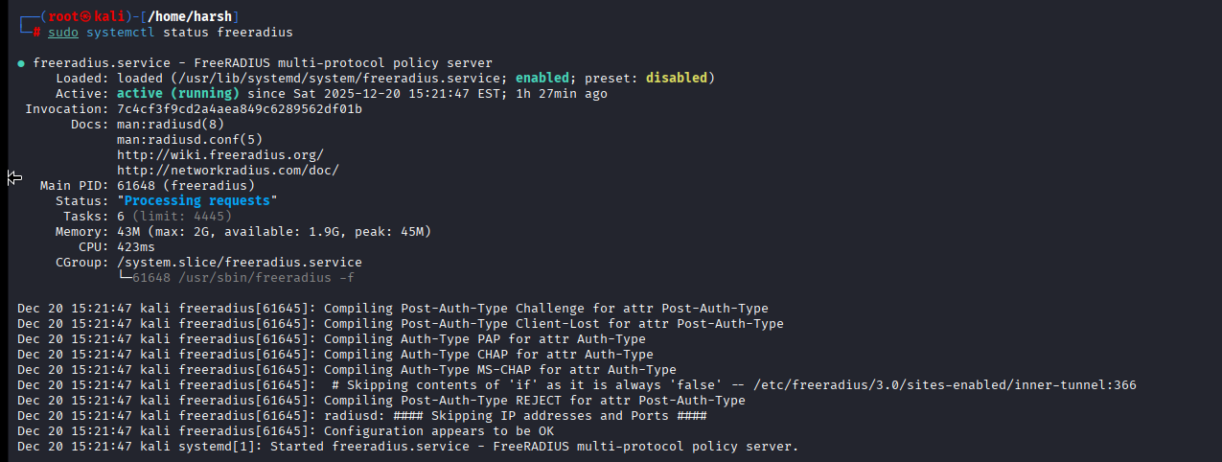

To implement secure enterprise-level Wi-Fi authentication, a WPA2-Enterprise authentication model was configured using a centralized RADIUS server. The Free RADIUS service was installed and verified to be running successfully. WPA2-Enterprise enhances wireless security by replacing shared pre-shared keys with centralized user authentication, ensuring that each user is individually authenticated before gaining access to the wireless network.

The active RADIUS service confirms the availability of a secure backend authentication mechanism required for enterprise Wi-Fi environments.

9.3.2 Secure Bluetooth Pairing and Authentication
Screenshot:
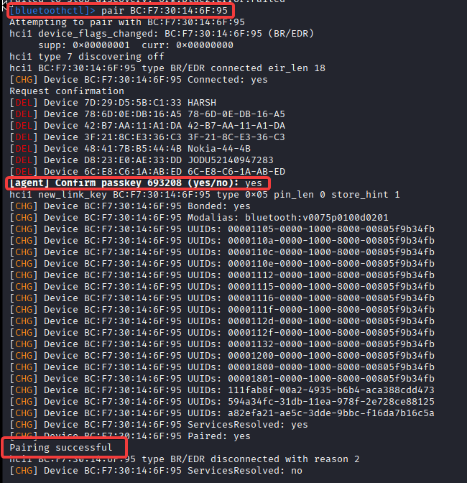
Secure Bluetooth pairing was implemented to ensure authenticated device connections. During the pairing process, a pairing request was generated, and user confirmation was required to establish the connection. The device was successfully paired only after authentication approval, preventing automatic or unauthorized Bluetooth connections.

The successful pairing and connection confirm that secure Bluetooth authentication mechanisms are enforced, reducing the risk of unauthorized device access and Bluetooth-based attacks.

9.3.3 Outcome of Secure Authentication Implementation
The implementation of WPA2-Enterprise authentication using a centralized RADIUS server and secure Bluetooth pairing mechanisms demonstrates strong authentication controls across wireless communication technologies. These measures significantly enhance access control, prevent unauthorized connections, and improve the overall security posture of both Wi-Fi and Bluetooth networks.

9.4 VPN Setup and Configuration (Practical)

9.4.1 VPN Client Configuration
Screenshot:
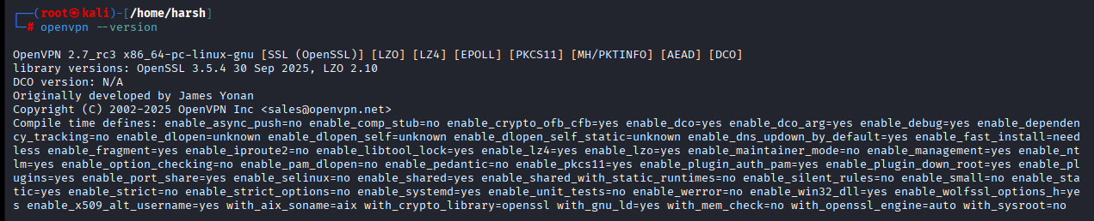
VPN activity was validated by observing IP address changes and encrypted TLS traffic in Wireshark, which also contributes to monitored events visible to IDS and network logs.To secure Wi-Fi communications, a VPN client was configured using OpenVPN. The OpenVPN client supports strong cryptographic protocols such as TLS and OpenSSL, enabling the creation of encrypted tunnels over wireless networks. This configuration ensures that data transmitted over Wi-Fi is protected from interception.

9.4.2 Verification of VPN Tunnel Using IP Address Change
Screenshot:
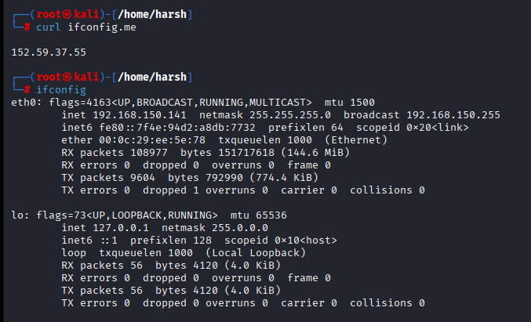
The effectiveness of the VPN connection was verified by observing a change in the system’s IP address after establishing the VPN tunnel. The change in IP address confirms that network traffic is being routed through the secure VPN tunnel rather than directly over the local Wi-Fi network.

9.4.3 Analysis of Encrypted VPN Traffic Using Wireshark
Screenshot:
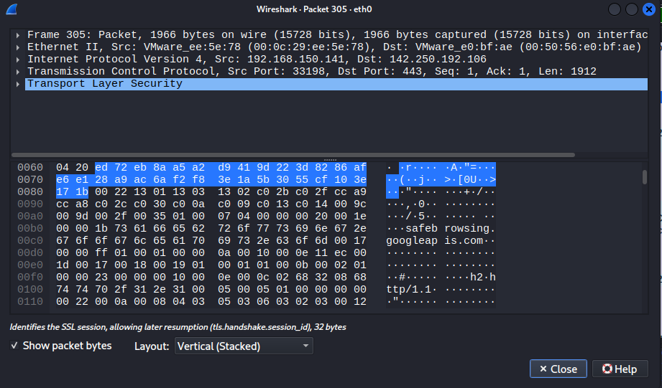
Wireshark was used to analyze network traffic after VPN configuration. The captured packets indicated encrypted communication using Transport Layer Security (TLS). No readable plaintext data was observed, confirming that the VPN effectively encrypts data transmitted over the Wi-Fi network.

9.5 End-to-End Encryption Implementation (Practical)

9.5.1 Data Encryption Verification of Encrypted Data
Screenshot:
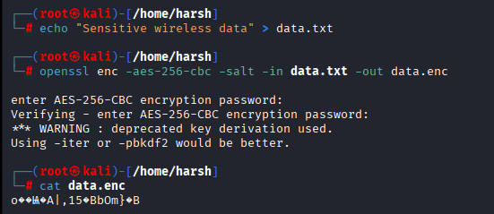
End-to-end encryption was implemented by encrypting a sample data file using a cryptographic tool. A strong encryption algorithm and password were applied to ensure that the data remains unreadable to unauthorized parties during transmission over Wi-Fi or Bluetooth networks. The encrypted file was examined to verify that its contents were unreadable and protected.

9.5.2 Successful Data Decryption and Integrity Verification
Screenshot:
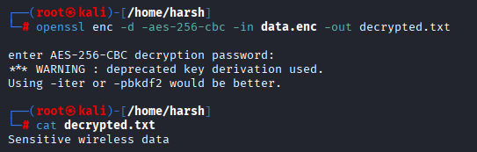
The encrypted file was successfully decrypted using the correct password. The decrypted output matched the original data, confirming the integrity and effectiveness of the end-to-end encryption process.

9.5.3 Outcome of Secure Data Transmission Implementation
The implementation of VPN-based secure tunneling and end-to-end encryption demonstrates strong protection of wireless data transmission. VPN technology ensures encrypted communication over Wi-Fi networks, while end-to-end encryption guarantees that sensitive data remains protected from sender to receiver, even if the network is compromised.

9.6 Network Segmentation and Access Control (Practical)

9.6.1 Access Control List (ACL) Rule Implementation:
Screenshot:
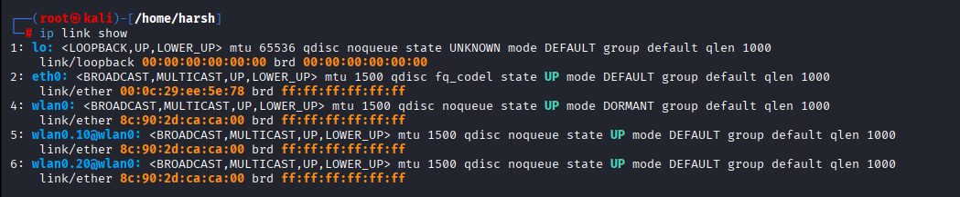
To enforce network segmentation, Access Control Lists (ACLs) were implemented using firewall rules. A specific rule was applied to block forwarded traffic between logically separated network segments. This rule ensures that devices in one segment are restricted from communicating with devices in another segment, thereby enforcing isolation between network zones.

9.6.2 Verification of Network Segmentation Enforcement
Screenshot:
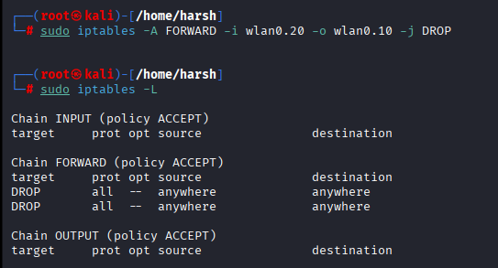
The applied ACL rules were verified by listing the active firewall rules. The presence of DROP rules in the FORWARD chain confirms that inter-segment traffic is blocked successfully. This verification demonstrates that network segmentation is actively enforced and that unauthorized lateral movement between network segments is prevented.

9.6.3 Access Control Lists Iptables:
Screenshot:
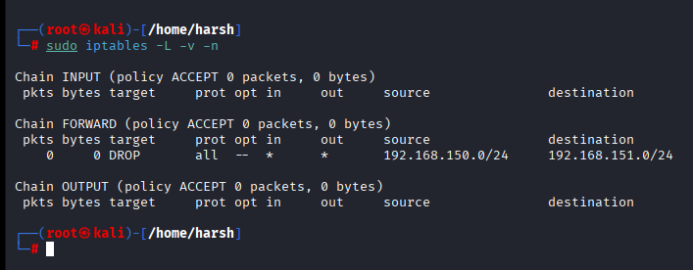
Access Control Lists (ACLs) were implemented using iptables to restrict inter-segment traffic. The FORWARD chain was configured with DROP rules to prevent unauthorized communication between network segments, validating effective network-layer segmentation.

9.6.4 Outcome of Network Segmentation
The implementation of access control rules effectively enforces logical network segmentation by restricting traffic flow between isolated segments. This approach improves wireless network security by minimizing attack propagation, reducing unauthorized access, and protecting sensitive network resources.

9.7 Intrusion Detection Systems (Practical)

9.7.1 Wi-Fi Intrusion Detection System Setup Using Snort
Screenshot:
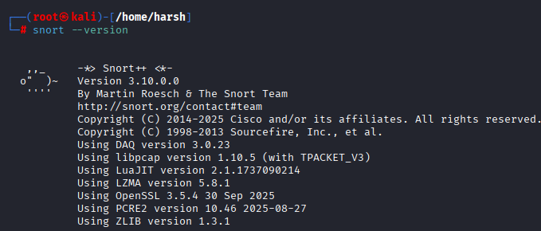
A Wi-Fi Intrusion Detection System (IDS) was implemented using the Snort tool. The Snort IDS was installed and verified to ensure availability for monitoring wireless network traffic. Snort provides real-time traffic inspection and detection capabilities to identify suspicious network activities.

9.7.2 IDS Initialization and Traffic Monitoring
Screenshot:
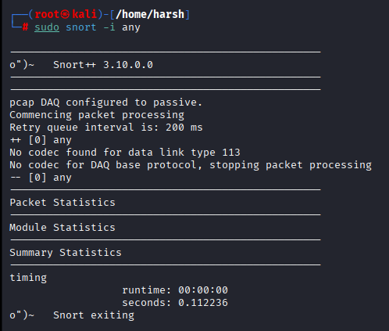
Snort was configured to monitor network traffic by initializing its packet capture engine. The IDS successfully started and attempted packet processing, demonstrating active intrusion detection capability. This setup confirms that wireless traffic can be monitored for potential security threats in real time.

9.7.3Snort Packet Processing Output
Screenshot:
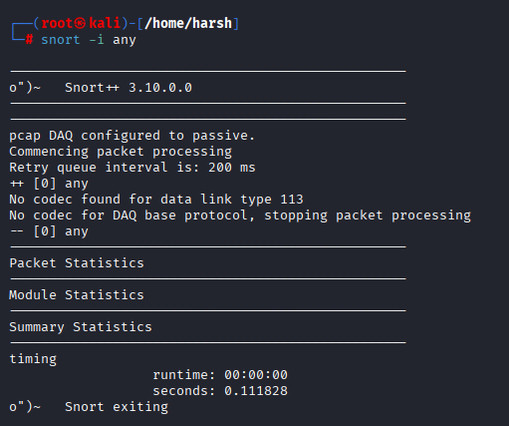
Snort++ was deployed in passive monitoring mode to observe wireless and network traffic. The IDS successfully initialized packet processing and generated runtime statistics, validating the operational readiness of the intrusion detection setup in the wireless security environment.

9.7.4 Bluetooth Connection Monitoring and Detection
Screenshot:
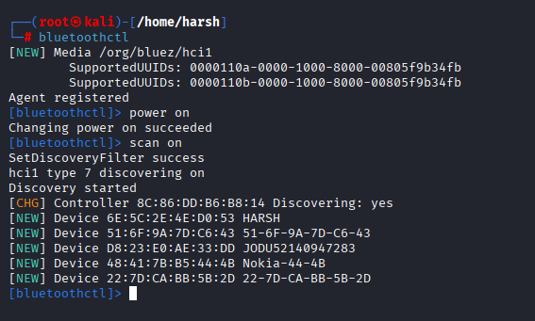
Bluetooth monitoring was enabled to detect nearby Bluetooth-enabled devices and connection attempts. The scanning process successfully identified surrounding devices, demonstrating the ability to monitor Bluetooth activity and detect unauthorized or unknown devices within range.

9.7.5 Real-Time Detection and Log Evidence
The deployment of Snort as a Wi-Fi IDS and the implementation of Bluetooth monitoring provide effective detection mechanisms for wireless networks. These controls enhance network visibility, enable early detection of suspicious activity, and strengthen the overall wireless security posture.

9.8 Policy Development

9.8.1 Wireless Security Policy Overview
Wireless security policies were defined to ensure safe usage of Wi-Fi and Bluetooth in the test environment. The policies aim to prevent unauthorized access, data interception, and misuse. Clear guidelines help maintain secure and controlled wireless communication.

9.8.2 Wi-Fi and Authentication Policy
All Wi-Fi networks must use strong encryption such as WPA2 or WPA3. Centralized authentication mechanisms are recommended for sensitive environments to prevent unauthorized access. Open or unsecured wireless networks are strictly prohibited.

9.8.3 Bluetooth and Secure Communication Policy
Bluetooth connections must use secure pairing with user authentication and confirmation. Unknown or untrusted devices are not permitted to connect automatically. Bluetooth monitoring should be enabled to detect nearby and unauthorized devices.

9.8.4 Monitoring, VPN, and Compliance Policy
VPNs and end-to-end encryption must be used to protect sensitive wireless data. Intrusion detection mechanisms should monitor Wi-Fi and Bluetooth activity continuously. These policies align with industry best practices and general regulatory security principles.

10.Threat Analysis
Wireless networks are highly susceptible to various security threats due to their open and broadcast-based communication nature. Attackers can intercept signals, exploit weak configurations, or impersonate trusted devices without requiring physical access to the organization’s infrastructure. This makes wireless communication an attractive target for cybercriminals.

One of the most common threats is unauthorized access, where attackers attempt to connect to a wireless network by exploiting weak passwords, outdated encryption, or unsecured access points. Such breaches can lead to data theft, unauthorized monitoring, or the launching of further attacks inside the network. Man-in-the-Middle (MITM) attacks also pose a severe risk, allowing attackers to intercept or alter wireless data during transmission.

Another significant threat involves packet sniffing, where attackers capture wireless traffic to collect sensitive information such as credentials, session tokens, or personal data. Bluetooth-specific threats, such as bluejacking, bluesnarfing, and unauthorized pairing, further increase the attack surface by exploiting device-to-device communication channels.

These threats highlight the need for secure configurations, robust encryption standards, and continuous monitoring to ensure that wireless communication remains protected against evolving attack techniques.

11.Findings
The analysis of wireless communication systems revealed several security weaknesses that could expose sensitive enterprise data to potential threats. Many Wi-Fi networks still rely on outdated encryption protocols such as WPA or WEP, which are vulnerable to brute-force attacks and packet-capture exploitation. Additionally, inconsistent configuration practices across access points increase the likelihood of unauthorized access.

The review of Bluetooth communication highlighted risks associated with insecure pairing methods and device discoverability. Several devices were found to operate in default or legacy modes, making them more susceptible to unauthorized connection attempts and data interception. Weak or absent authentication mechanisms further increase exposure to targeted Bluetooth attacks.

The assessment also identified gaps in network monitoring and logging, which limit the ability to detect suspicious wireless activities in real time. Lack of centralized visibility allows attackers to perform reconnaissance or launch MITM attacks without immediate detection. These findings indicate the need for strengthened security protocols and improved operational practices to protect wireless communication within enterprise environments.

12.Recommendations
To strengthen wireless network security, organizations should adopt modern encryption protocols such as WPA3 and disable legacy standards like WEP and WPA. Implementing strong, complex passwords for Wi-Fi access and enforcing secure authentication methods will significantly reduce the likelihood of unauthorized access.

It is recommended to configure Bluetooth devices to operate in non-discoverable mode and use secure pairing mechanisms to prevent unauthorized connections. Devices should be regularly updated to ensure they are protected against known Bluetooth-based attacks and vulnerabilities.

Organizations should also implement centralized monitoring tools to detect suspicious wireless activities in real time. Solutions such as wireless intrusion detection systems (WIDS) and detailed logging can help identify potential attacks early and support incident response. Regular security audits, configuration reviews, and vulnerability assessments should be conducted to maintain strong security hygiene.

13.Conclusion
Wireless communication is essential for modern enterprise operations, but it introduces significant security risks when not properly configured or managed. The analysis conducted during this project highlights how weaknesses in Wi-Fi and Bluetooth technologies can expose sensitive information to unauthorized access, interception, and manipulation.

The findings emphasize the importance of implementing strong encryption, secure authentication methods, and effective configuration practices to safeguard wireless data transmission. Organizations must remain proactive by continuously monitoring wireless activity, updating outdated protocols, and conducting regular security assessments to identify emerging threats.

By adopting the recommended security measures, enterprises can enhance the confidentiality, integrity, and availability of their wireless communication systems. Strengthening wireless security not only protects critical business information but also supports compliance, operational continuity, and overall organizational resilience.

14.References
The following sources were reviewed to support the analysis of wireless network security, industry standards, and common attack techniques. These references include technical documentation, cybersecurity frameworks, and research-based materials relevant to Wi-Fi and Bluetooth security.

- IEEE 802.11 Wireless Standards Documentation – Institute of Electrical and Electronics Engineers (IEEE).
- Wi-Fi Alliance Security Guidelines – WPA2 and WPA3 Technical Specifications.
- NIST Special Publication 800-153 – Guidelines for Securing Wireless Local Area Networks (WLANs).
- NIST Special Publication 800-121 Rev. 2 – Guide to Bluetooth Security.
- OWASP Wireless Security Testing Guide – Open Web Application Security Project (OWASP).
- Bluetooth SIG Documentation – Bluetooth Core Specification and Security Features.
- SANS Institute Reading Room – Research papers on wireless threats and intrusion detection.
- CISA Guidelines – Best practices for securing wireless networks and preventing unauthorized access.

Additional internal research and observations from the organization’s network environment were also incorporated into the assessment.

